Most papers stop at detection part, but since we are working on an advanced security system, we provide a complete platform (monitoring + detection + response)
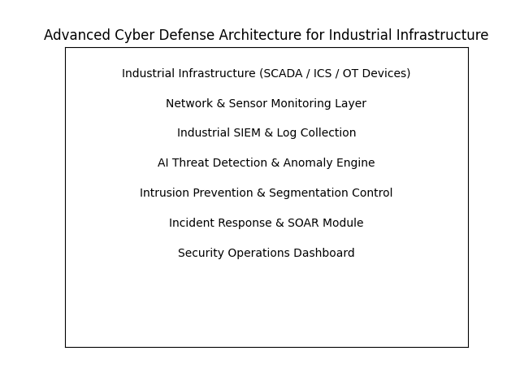
Multi-Layer Detection (Network + Physical Process)
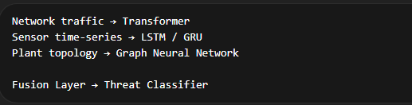
Almost no papers combine all three domains simultaneously.

Feature | Existing Papers | Your System
Detection | Yes | Yes
Multi-source data | Rare | Yes
Explainable AI | No | Yes
Autonomous response | Rare | Yes
Digital twin training | Limited | Yes
Full security platform | No | Yes

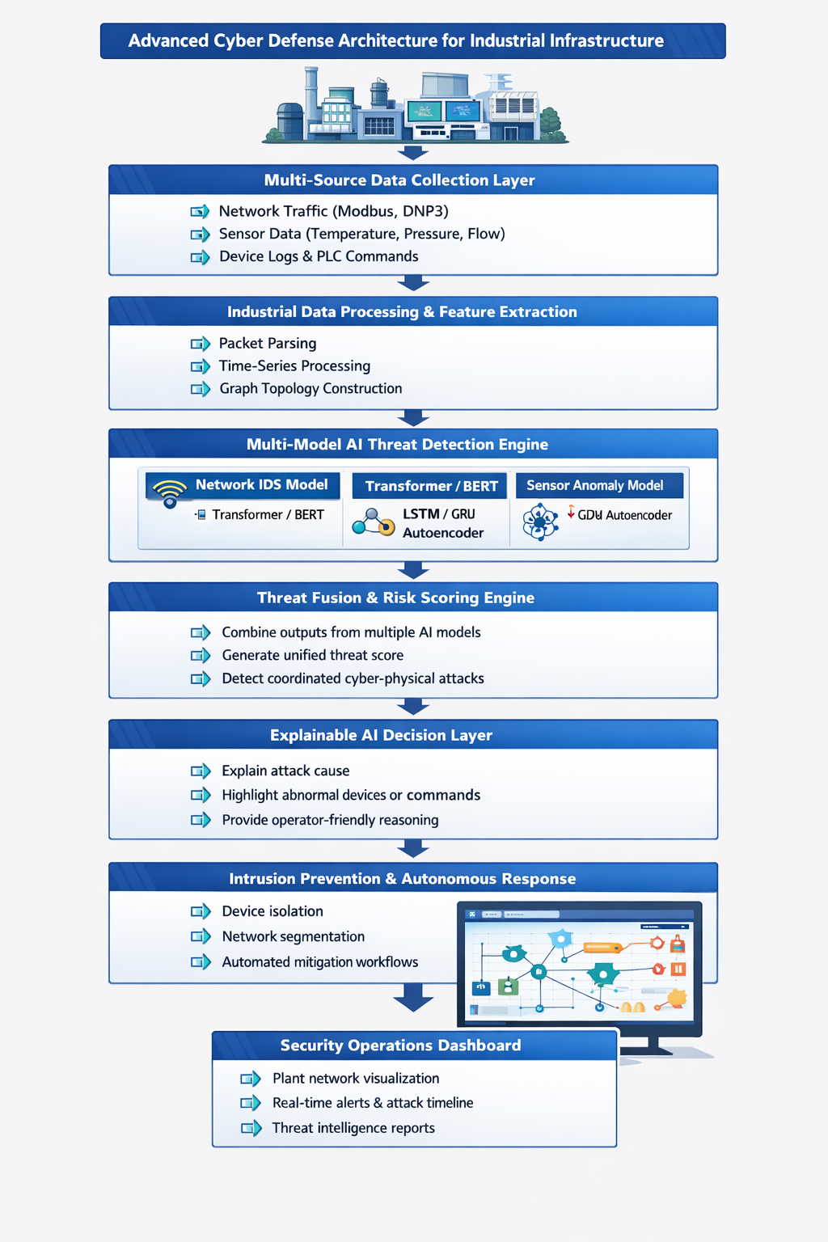
Component | Algorithm
Sensor anomaly detection | LSTM / GRU Autoencoder
Network intrusion detection | Transformer / BERT
Topology monitoring | Graph Neural Network
Threat correlation | Weighted fusion scoring
Explainability | SHAP
Response system | Rule engine / RL

Datasets
Dataset | Purpose
SWaT | Industrial sensor anomaly detection
WADI | Water distribution ICS attacks
CICIDS | Network intrusion detection

Methodology
The proposed system follows a multi-layer cyber-physical security approach to detect and respond to attacks targeting Industrial Control Systems (ICS). The methodology integrates data collection, preprocessing, machine learning-based anomaly detection, threat correlation, and automated response.

System Data Acquisition
The first step is collecting data from the industrial environment.
Data Sources
The system gathers information from three domains:
1. Network Layer
- Industrial communication packets
- Protocol commands (Modbus, DNP3, OPC-UA)
2. Physical Process Layer
- Sensor readings (pressure, temperature, flow rate, tank level)
3. Device / Control Layer
- PLC commands
- Device logs and communication events
Data Collection Techniques
Network Tap / Port Mirroring
Packet Capture Tools
Industrial Gateway Monitoring
Sensor Data Streams
The collected data is stored in a central monitoring server for further processing.

2. Data Preprocessing and Feature Engineering
Raw industrial data cannot be used directly for machine learning.
Steps
Data Cleaning
- Remove missing values
- Handle noisy sensor readings
Normalization
- Scale sensor values between 0 and 1
Feature Extraction
Examples of features extracted:
Network Features
- source IP
- destination IP
- packet size
- protocol type
- command type
Process Features
- pressure value
- flow rate
- temperature
- actuator state
Temporal Features
- sensor change rate
- command frequency
- time interval between packets
After feature engineering, the data is converted into structured input vectors for the machine learning models.

3. Model Training Phase
The system trains multiple machine learning models to understand normal behavior of industrial systems.
Model 1 — Sensor Anomaly Detection
Algorithm used:
LSTM / GRU Autoencoder
Purpose:
Detect anomalies in industrial process variables.
Training process:
Normal sensor data → Train Autoencoder
Model learns normal process patterns
High reconstruction error → anomaly

Model 2 — Network Intrusion Detection
Algorithm used:
Transformer / BERT-based IDS
Purpose:
Detect malicious commands and abnormal network communication.
Training process:
Network packet sequences
→ Tokenization
→ Transformer embedding
→ Classification
The model learns normal industrial network traffic patterns.

Model 3 — Topology-Based Detection
Algorithm used:
Graph Neural Network (GNN)
Industrial networks are represented as graphs:
Nodes = PLCs, sensors, devices
Edges = communication links
The GNN learns normal device communication relationships.
Abnormal connections indicate possible attacks.

4. Real-Time Anomaly Detection
Once models are trained, the system performs real-time monitoring.
Incoming industrial data flows through the detection pipeline.
Detection flow:
Industrial Data
↓
Feature Extraction
↓
Sensor Model (LSTM)
Network Model (Transformer)
Topology Model (GNN)
↓
Generate anomaly scores
Each model produces an anomaly score.

5. Threat Fusion and Risk Scoring
Instead of relying on a single model, the system combines outputs from multiple models.
Threat Fusion Algorithm
ThreatScore =
0.4 × Sensor Anomaly Score
+ 0.4 × Network Anomaly Score
+ 0.2 × Topology Anomaly Score
This allows the system to detect cyber-physical attacks that affect both network behavior and physical processes.

6. Explainable AI Analysis
To make the system understandable to industrial operators, an Explainable AI module is implemented.
Technique used:
SHAP (Shapley Additive Explanations)
The module identifies the factors responsible for anomaly detection.
Example explanation:
Attack Detected: PLC Command Injection
Reasons:
• abnormal Modbus write command
• sudden pressure spike
• unauthorized device communication

7. Automated Incident Response
Once a threat is confirmed, the system triggers containment actions.
Response Engine
Possible mitigation strategies:
Block malicious IP address
Isolate compromised PLC
Disable unauthorized command execution
Segment affected network zone
Switch system to safe operational mode
A rule-based decision engine determines the appropriate response based on the threat score.

8. Security Monitoring Dashboard
The final component is a Security Operations Dashboard that provides real-time visibility.
The dashboard displays:
industrial network topology
detected anomalies
device risk scores
attack timeline
system health metrics
Operators can monitor system behaviour and take additional actions if necessary.

